#
# 20200204
#

https://fsd.tcsbank.ru/case/3680064/info

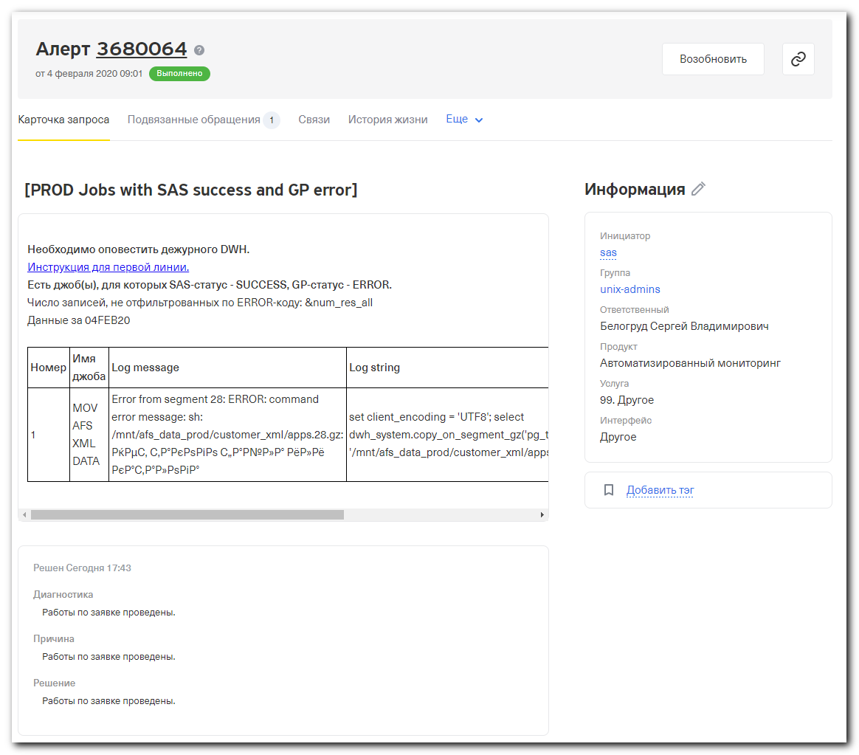
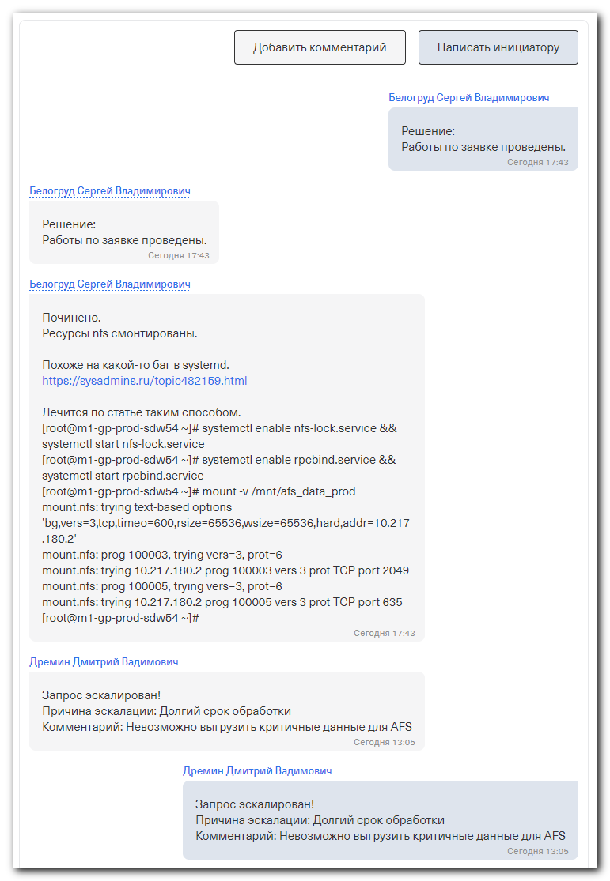
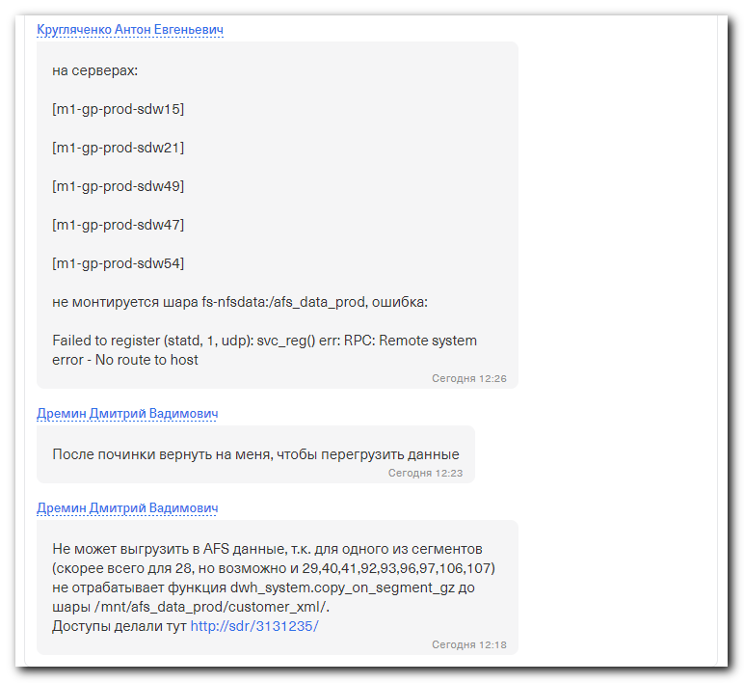

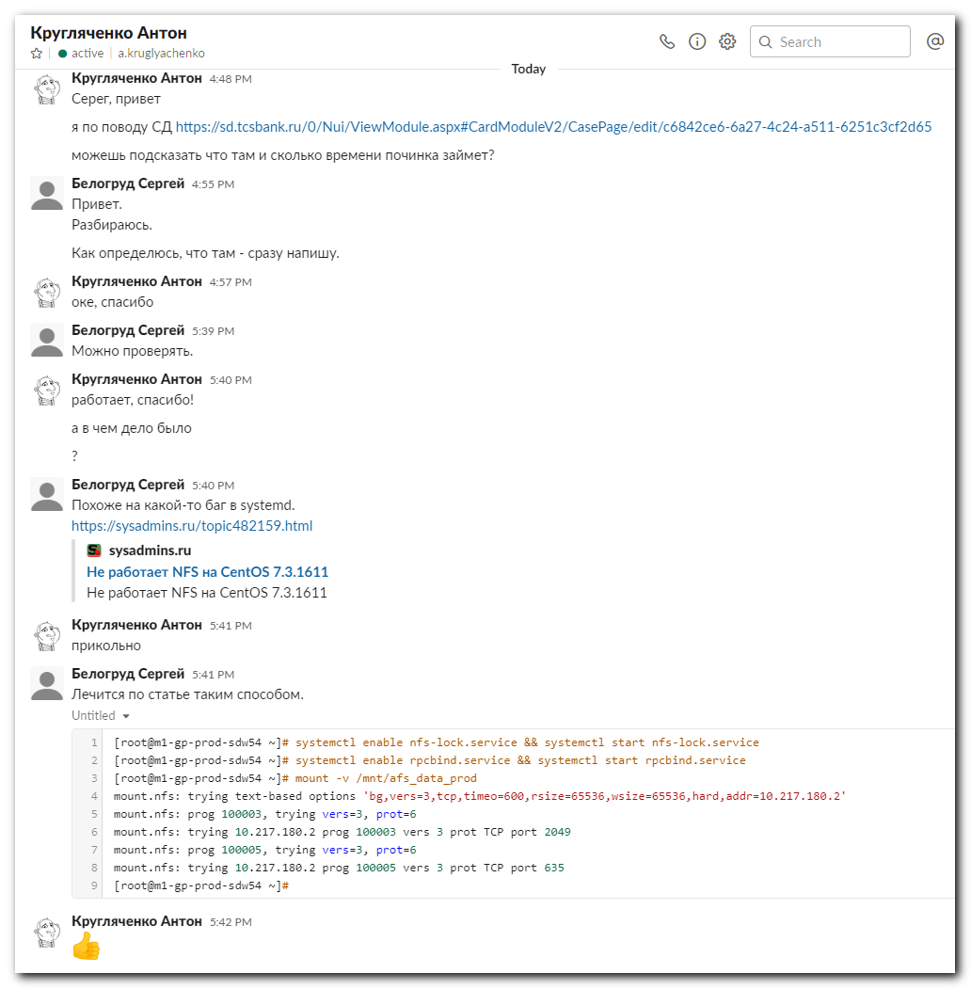

[17:18:35 root@m1-gp-prod-sdw15 ~]# journalctl -xe
...
-- The start-up result is done.
Feb 04 17:11:01 m1-gp-prod-sdw15 CROND[155069]: (root) CMD (/usr/lib64/sa/sa1 1 1)
Feb 04 17:11:01 m1-gp-prod-sdw15 systemd[1]: Removed slice User Slice of root.
-- Subject: Unit user-0.slice has finished shutting down
-- Defined-By: systemd
-- Support: http://lists.freedesktop.org/mailman/listinfo/systemd-devel
--
-- Unit user-0.slice has finished shutting down.
Feb 04 17:11:02 m1-gp-prod-sdw15 polkitd[19997]: Registered Authentication Agent for unix-process:155103:311482869 (system bus name :1.145624 [/usr/bin/pkttyagent --notify-fd 5 --fallback], object path /org/f
Feb 04 17:11:02 m1-gp-prod-sdw15 systemd[1]: rpcbind.socket failed to listen on sockets: Address family not supported by protocol
Feb 04 17:11:02 m1-gp-prod-sdw15 systemd[1]: Failed to listen on RPCbind Server Activation Socket.
-- Subject: Unit rpcbind.socket has failed
-- Defined-By: systemd
-- Support: http://lists.freedesktop.org/mailman/listinfo/systemd-devel
...
Feb 04 17:11:02 m1-gp-prod-sdw15 systemd[1]: Dependency failed for NFS status monitor for NFSv2/3 locking..
-- Subject: Unit rpc-statd.service has failed
-- Defined-By: systemd
-- Support: http://lists.freedesktop.org/mailman/listinfo/systemd-devel
--
-- Unit rpc-statd.service has failed.
--
-- The result is dependency.
Feb 04 17:11:02 m1-gp-prod-sdw15 systemd[1]: Job rpc-statd.service/start failed with result 'dependency'.
Feb 04 17:11:02 m1-gp-prod-sdw15 systemd[1]: Starting Preprocess NFS configuration...
-- Subject: Unit nfs-config.service has begun start-up
-- Defined-By: systemd
-- Support: http://lists.freedesktop.org/mailman/listinfo/systemd-devel
--
-- Unit nfs-config.service has begun starting up.
Feb 04 17:11:02 m1-gp-prod-sdw15 polkitd[19997]: Unregistered Authentication Agent for unix-process:155103:311482869 (system bus name :1.145624, object path /org/freedesktop/PolicyKit1/AuthenticationAgent, lo
Feb 04 17:11:02 m1-gp-prod-sdw15 systemd[1]: Started Preprocess NFS configuration.
-- Subject: Unit nfs-config.service has finished start-up
-- Defined-By: systemd
-- Support: http://lists.freedesktop.org/mailman/listinfo/systemd-devel
--
-- Unit nfs-config.service has finished starting up.
--
-- The start-up result is done.
Feb 04 17:11:02 m1-gp-prod-sdw15 rpc.statd[155112]: Version 1.3.0 starting
Feb 04 17:11:02 m1-gp-prod-sdw15 rpc.statd[155112]: Flags: TI-RPC
Feb 04 17:11:02 m1-gp-prod-sdw15 rpc.statd[155112]: Failed to register (statd, 1, udp): svc_reg() err: RPC: Remote system error - No route to host
Feb 04 17:11:02 m1-gp-prod-sdw15 rpc.statd[155112]: Failed to register (statd, 1, tcp): svc_reg() err: RPC: Remote system error - No route to host
Feb 04 17:11:02 m1-gp-prod-sdw15 rpc.statd[155112]: Failed to register (statd, 1, udp6): svc_reg() err: RPC: Remote system error - No route to host
Feb 04 17:11:02 m1-gp-prod-sdw15 rpc.statd[155112]: Failed to register (statd, 1, tcp6): svc_reg() err: RPC: Remote system error - No route to host
Feb 04 17:11:02 m1-gp-prod-sdw15 rpc.statd[155112]: failed to create RPC listeners, exiting
...

[17:19:00 root@m1-gp-prod-sdw15 ~]# systemctl status nfs
● nfs-server.service - NFS server and services
Loaded: loaded (/usr/lib/systemd/system/nfs-server.service; disabled; vendor preset: disabled)
Active: inactive (dead)
[17:19:31 root@m1-gp-prod-sdw15 ~]# systemctl status rpcbind
● rpcbind.service - RPC bind service
Loaded: loaded (/usr/lib/systemd/system/rpcbind.service; enabled; vendor preset: enabled)
Active: inactive (dead)

Dec 30 15:57:28 m1-gp-prod-sdw15 systemd[1]: Dependency failed for RPC bind service.
Dec 30 15:57:28 m1-gp-prod-sdw15 systemd[1]: Job rpcbind.service/start failed with result 'dependency'.
[17:19:39 root@m1-gp-prod-sdw15 ~]#

[17:19:39 root@m1-gp-prod-sdw15 ~]# systemctl start rpcbind
A dependency job for rpcbind.service failed. See 'journalctl -xe' for details.
[17:20:30 root@m1-gp-prod-sdw15 ~]#

[17:24:55 root@m1-gp-prod-sdw15 ~]# journalctl -xe
...
Feb 04 17:20:30 m1-gp-prod-sdw15 systemd[1]: Dependency failed for RPC bind service.
-- Subject: Unit rpcbind.service has failed
-- Defined-By: systemd
-- Support: http://lists.freedesktop.org/mailman/listinfo/systemd-devel
--
-- Unit rpcbind.service has failed.
--
-- The result is dependency.
Feb 04 17:20:30 m1-gp-prod-sdw15 systemd[1]: Job rpcbind.service/start failed with result 'dependency'.
Feb 04 17:20:30 m1-gp-prod-sdw15 polkitd[19997]: Unregistered Authentication Agent for unix-process:169352:311539682 (system bus name :1.145649, object path /org/freedesktop/PolicyKit1/AuthenticationAgent, lo
Feb 04 17:20:44 m1-gp-prod-sdw15 python[20028]: 1580826044.05 [NetworkCollector:20479:DEBUG] Collection took 18 ms
Feb 04 17:20:49 m1-gp-prod-sdw15 python[20028]: 1580826049.58 [CPUCollector:20457:DEBUG] Collection took 1004 ms

[17:24:53 root@m1-gp-prod-sdw15 ~]# systemctl cat rpcbind.socket
# /usr/lib/systemd/system/rpcbind.socket
[Unit]
Description=RPCbind Server Activation Socket

[Socket]
ListenStream=/var/run/rpcbind.sock

# RPC netconfig can't handle ipv6/ipv4 dual sockets
BindIPv6Only=ipv6-only
ListenStream=0.0.0.0:111
ListenDatagram=0.0.0.0:111
ListenStream=[::]:111
ListenDatagram=[::]:111

[Install]
WantedBy=sockets.target
[17:24:55 root@m1-gp-prod-sdw15 ~]#

[17:24:55 root@m1-gp-prod-sdw15 ~]# systemctl status nfs-lock.service
● rpc-statd.service - NFS status monitor for NFSv2/3 locking.
Loaded: loaded (/usr/lib/systemd/system/rpc-statd.service; static; vendor preset: disabled)
Active: inactive (dead)

Dec 30 15:57:35 m1-gp-prod-sdw15 systemd[1]: Dependency failed for NFS status monitor for NFSv2/3 locking..
Dec 30 15:57:35 m1-gp-prod-sdw15 systemd[1]: Job rpc-statd.service/start failed with result 'dependency'.
Feb 04 12:16:55 m1-gp-prod-sdw15 systemd[1]: Dependency failed for NFS status monitor for NFSv2/3 locking..
Feb 04 12:16:55 m1-gp-prod-sdw15 systemd[1]: Job rpc-statd.service/start failed with result 'dependency'.
Feb 04 12:18:32 m1-gp-prod-sdw15 systemd[1]: Dependency failed for NFS status monitor for NFSv2/3 locking..
Feb 04 12:18:32 m1-gp-prod-sdw15 systemd[1]: Job rpc-statd.service/start failed with result 'dependency'.
Feb 04 12:23:42 m1-gp-prod-sdw15 systemd[1]: Dependency failed for NFS status monitor for NFSv2/3 locking..
Feb 04 12:23:42 m1-gp-prod-sdw15 systemd[1]: Job rpc-statd.service/start failed with result 'dependency'.
Feb 04 17:11:02 m1-gp-prod-sdw15 systemd[1]: Dependency failed for NFS status monitor for NFSv2/3 locking..
Feb 04 17:11:02 m1-gp-prod-sdw15 systemd[1]: Job rpc-statd.service/start failed with result 'dependency'.
[17:26:33 root@m1-gp-prod-sdw15 ~]#

[17:26:33 root@m1-gp-prod-sdw15 ~]# systemctl start nfs-lock.service
A dependency job for rpc-statd.service failed. See 'journalctl -xe' for details.
[17:29:32 root@m1-gp-prod-sdw15 ~]# systemctl enable nfs-lock.service
[17:29:52 root@m1-gp-prod-sdw15 ~]# systemctl start nfs-lock.service
[17:29:56 root@m1-gp-prod-sdw15 ~]# systemctl enable rpcbind.service
[17:30:13 root@m1-gp-prod-sdw15 ~]# systemctl start rpcbind.service
[17:30:17 root@m1-gp-prod-sdw15 ~]#

[17:30:37 root@m1-gp-prod-sdw15 ~]# systemctl status rpcbind.service
● rpcbind.service - RPC bind service
Loaded: loaded (/usr/lib/systemd/system/rpcbind.service; enabled; vendor preset: enabled)
Active: active (running) since Tue 2020-02-04 17:29:56 MSK; 1min 1s ago
Main PID: 185883 (rpcbind)
CGroup: /system.slice/rpcbind.service
└─185883 /sbin/rpcbind -w

Feb 04 17:29:56 m1-gp-prod-sdw15 systemd[1]: Starting RPC bind service...
Feb 04 17:29:56 m1-gp-prod-sdw15 systemd[1]: Started RPC bind service.
[17:30:57 root@m1-gp-prod-sdw15 ~]# systemctl status nfs-lock.service
● rpc-statd.service - NFS status monitor for NFSv2/3 locking.
Loaded: loaded (/usr/lib/systemd/system/rpc-statd.service; static; vendor preset: disabled)
Active: active (running) since Tue 2020-02-04 17:29:56 MSK; 1min 8s ago
Main PID: 185884 (rpc.statd)
CGroup: /system.slice/rpc-statd.service
└─185884 /usr/sbin/rpc.statd

Feb 04 17:29:56 m1-gp-prod-sdw15 systemd[1]: Starting NFS status monitor for NFSv2/3 locking....
Feb 04 17:29:56 m1-gp-prod-sdw15 rpc.statd[185884]: Version 1.3.0 starting
Feb 04 17:29:56 m1-gp-prod-sdw15 rpc.statd[185884]: Flags: TI-RPC
Feb 04 17:29:56 m1-gp-prod-sdw15 systemd[1]: Started NFS status monitor for NFSv2/3 locking..
[17:31:04 root@m1-gp-prod-sdw15 ~]#

[17:31:04 root@m1-gp-prod-sdw15 ~]# grep -ie "nfsdata" /etc/fstab
fs-nfsdata:/afs_data_prod /mnt/afs_data_prod nfs rw,bg,vers=3,tcp,timeo=600,rsize=65536,wsize=65536,hard 0 0
[17:31:20 root@m1-gp-prod-sdw15 ~]# ls -Alh /mnt/afs_data_prod
total 0
[17:31:29 root@m1-gp-prod-sdw15 ~]# mount -v /mnt/afs_data_prod
mount.nfs: trying text-based options 'bg,vers=3,tcp,timeo=600,rsize=65536,wsize=65536,hard,addr=10.217.180.2'
mount.nfs: prog 100003, trying vers=3, prot=6
mount.nfs: trying 10.217.180.2 prog 100003 vers 3 prot TCP port 2049
mount.nfs: prog 100005, trying vers=3, prot=6
mount.nfs: trying 10.217.180.2 prog 100005 vers 3 prot TCP port 635
[17:31:34 root@m1-gp-prod-sdw15 ~]#

[17:31:34 root@m1-gp-prod-sdw15 ~]# ls /mnt/afs_data_prod
2019-10-22-20-00-58.done 2019-10-30-20-01-04.done 2019-12-13-20-01-12.done 2019-12-19-12-01-49.done 2019-12-27-20-01-05.done 2020-01-05-20-01-06.done
...
[17:31:53 root@m1-gp-prod-sdw15 ~]#

[17:32:49 root@m1-gp-prod-sdw21 ~]# systemctl status rpcbind.service
● rpcbind.service - RPC bind service
Loaded: loaded (/usr/lib/systemd/system/rpcbind.service; enabled; vendor preset: enabled)
Active: inactive (dead)
[17:33:03 root@m1-gp-prod-sdw21 ~]# systemctl status nfs-lock.service
● rpc-statd.service - NFS status monitor for NFSv2/3 locking.
Loaded: loaded (/usr/lib/systemd/system/rpc-statd.service; static; vendor preset: disabled)
Active: inactive (dead)
[17:33:20 root@m1-gp-prod-sdw21 ~]#

[17:33:20 root@m1-gp-prod-sdw21 ~]# mount -v /mnt/afs_data_prod
A dependency job for rpc-statd.service failed. See 'journalctl -xe' for details.
mount.nfs: rpc.statd is not running but is required for remote locking.
mount.nfs: Either use '-o nolock' to keep locks local, or start statd.
mount.nfs: an incorrect mount option was specified
[17:33:58 root@m1-gp-prod-sdw21 ~]#

[17:33:58 root@m1-gp-prod-sdw21 ~]# systemctl enable nfs-lock.service
[17:34:39 root@m1-gp-prod-sdw21 ~]# systemctl enable rpcbind.service
[17:34:51 root@m1-gp-prod-sdw21 ~]# systemctl start nfs-lock.service
[17:35:04 root@m1-gp-prod-sdw21 ~]# systemctl start rpcbind.service
[17:35:10 root@m1-gp-prod-sdw21 ~]# mount -v /mnt/afs_data_prod
mount.nfs: trying text-based options 'bg,vers=3,tcp,timeo=600,rsize=65536,wsize=65536,hard,addr=10.217.180.2'
mount.nfs: prog 100003, trying vers=3, prot=6
mount.nfs: trying 10.217.180.2 prog 100003 vers 3 prot TCP port 2049
mount.nfs: prog 100005, trying vers=3, prot=6
mount.nfs: trying 10.217.180.2 prog 100005 vers 3 prot TCP port 635
[17:35:16 root@m1-gp-prod-sdw21 ~]#

[s.belogrud@TCS4357]# ssh bsv@m1-gp-prod-sdw49
[bsv@m1-gp-prod-sdw49 ~]$ sudo -i
[sudo] password for bsv:
ABRT has detected 1 problem(s). For more info run: abrt-cli list --since 1572958085
[root@m1-gp-prod-sdw49 ~]# systemctl enable nfs-lock.service
[root@m1-gp-prod-sdw49 ~]# systemctl start nfs-lock.service
[root@m1-gp-prod-sdw49 ~]# systemctl enable rpcbind.service
[root@m1-gp-prod-sdw49 ~]# systemctl start rpcbind.service
[root@m1-gp-prod-sdw49 ~]# mount -v /mnt/afs_data_prod
mount.nfs: trying text-based options 'bg,vers=3,tcp,timeo=600,rsize=65536,wsize=65536,hard,addr=10.217.180.2'
mount.nfs: prog 100003, trying vers=3, prot=6
mount.nfs: trying 10.217.180.2 prog 100003 vers 3 prot TCP port 2049
mount.nfs: prog 100005, trying vers=3, prot=6
mount.nfs: trying 10.217.180.2 prog 100005 vers 3 prot TCP port 635
[root@m1-gp-prod-sdw49 ~]#

[root@m1-gp-prod-sdw47 ~]# systemctl enable nfs-lock.service && systemctl start nfs-lock.service
[root@m1-gp-prod-sdw47 ~]# systemctl enable rpcbind.service && systemctl start rpcbind.service
[root@m1-gp-prod-sdw47 ~]# mount -v /mnt/afs_data_prod
mount.nfs: trying text-based options 'bg,vers=3,tcp,timeo=600,rsize=65536,wsize=65536,hard,addr=10.217.180.2'
mount.nfs: prog 100003, trying vers=3, prot=6
mount.nfs: trying 10.217.180.2 prog 100003 vers 3 prot TCP port 2049
mount.nfs: prog 100005, trying vers=3, prot=6
mount.nfs: trying 10.217.180.2 prog 100005 vers 3 prot TCP port 635
[root@m1-gp-prod-sdw47 ~]#

[root@m1-gp-prod-sdw54 ~]# systemctl enable nfs-lock.service && systemctl start nfs-lock.service
[root@m1-gp-prod-sdw54 ~]# systemctl enable rpcbind.service && systemctl start rpcbind.service
[root@m1-gp-prod-sdw54 ~]# mount -v /mnt/afs_data_prod
mount.nfs: trying text-based options 'bg,vers=3,tcp,timeo=600,rsize=65536,wsize=65536,hard,addr=10.217.180.2'
mount.nfs: prog 100003, trying vers=3, prot=6
mount.nfs: trying 10.217.180.2 prog 100003 vers 3 prot TCP port 2049
mount.nfs: prog 100005, trying vers=3, prot=6
mount.nfs: trying 10.217.180.2 prog 100005 vers 3 prot TCP port 635
[root@m1-gp-prod-sdw54 ~]#

https://sysadmins.ru/topic482159.html

